
Archives available at journals.mriindia.com

International Journal on Advanced Electrical and Computer Engineering

ISSN: 2349-9338

Volume 15 Issue 01, 2026

Real-Time Language Translator Using Raspberry Pi and Python

¹S. B. Patil, ²Aditya K. Pote, ³Pratiksha G. Ramtirthakar, ⁴Prathmesh G. Bhandugare
¹Principal, Professor, Electronics and Telecommunication, Dr. J. J. Magdum College of Engineering Jaysingpur, India
^{2,3,4} Electronics and Telecommunication, Dr. J. J. Magdum College of Engineering Jaysingpur , India
Email: ¹poteaditya110@gmail.com, ²ramtirthakarpratiksha2004@gmail.com, ³Prathmeshbhandugare274@gmail.com

Peer Review Information  Submission: 10 April 2026  Revision: 01 May 2026  Acceptance: 22 May 2026  Keywords  Raspberry Pi, Automated Speech Recognition, Real-Time Translation, Python Programming, Embedded Systems, Natural Language Processing. | Abstract  Language diversity across the globe poses significant challenges to seamless human interaction, particularly in domains such as healthcare, academia, commerce, and tourism. Countries with high linguistic diversity, such as India, often require individuals to depend on human interpreters for cross-language communication — a resource that is expensive and inconsistently available. This study proposes a novel embedded system solution: a portable, cost-effective Real-Time Language Translator built on the Raspberry Pi platform and developed using Python. The system acquires spoken input via a microphone, applies automated speech recognition (ASR) to generate text, employs machine translation to convert the text into a chosen target language, and finally synthesizes the translated content as audible speech. The implementation leverages widely-used Python libraries, namely SpeechRecognition, Googletrans, gTTS, and PyAudio. Evaluation results demonstrate translation accuracy ranging  from 85% to 95%, influenced primarily by pronunciation quality and network stability. This prototype effectively showcases the integration of embedded computing with natural language processing technologies.

Introduction
The capacity for effective communication forms the bedrock of human civilization. Nevertheless, linguistic differences continue to hinder meaningful exchange among individuals from distinct cultural and regional backgrounds. In a world increasingly connected through technology and trade, overcoming language barriers has become a critical challenge — particularly in multilingual nations and international contexts. Modern advances in embedded computing and Natural Language Processing (NLP) have made it feasible to deploy intelligent translation solutions at a fraction of the cost associated with traditional hardware. This research details the conception and realization of a real-time spoken language translator utilizing Raspberry Pi as the computational core, addressing an urgent need for affordable and accessible cross-language communication.

1. Problem Statement
Although digital translation tools and mobile applications have grown in availability, significant communication gaps persist. Existing solutions frequently rely on personal smartphones, consistent internet access, and active user involvement. Professional human translators incur high fees and may not be reachable in remote locations or time-critical situations. In underserved communities and educational environments, the gap between demand and access to linguistic assistance remains wide. This project addresses that gap by developing an autonomous, low-cost translation system that requires minimal user interaction and can operate with standard hardware components.
2. Linguistic Diversity
The coexistence of multiple languages within a single region or nation, known as linguistic diversity, is both a cultural asset and a practical challenge. India exemplifies this complexity, with 22 constitutionally recognized languages and a multitude of regional dialects spoken across its states. On a global scale, linguists estimate that over 7,000 distinct languages are actively spoken by human populations. While this richness fosters cultural identity and heritage, it simultaneously creates barriers for individuals navigating foreign linguistic environments — whether as travelers, students, healthcare patients, or workers. An embedded real-time translation tool has the potential to bridge these divides, promoting greater social inclusion and accessibility.
3. Problem to Solve
The core issue targeted by this project is the absence of an affordable, standalone device capable of facilitating real-time spoken communication between individuals using different languages. Current market offerings fall into two categories: smartphone-based applications that depend heavily on internet connectivity, and commercial translation devices that carry significant cost. Neither option is well-suited to resource-constrained environments. The proposed system fills this gap by offering a compact, embedded solution that can autonomously capture, translate, and relay speech with minimal latency and operational complexity.
4. Purpose of the Study
The central objective of this work is to engineer and validate a functional, low-cost real-time language translator using Raspberry Pi and Python as the primary development environment. By combining ASR, neural machine translation, and text-to-speech synthesis into a cohesive pipeline, this project aims to facilitate smooth verbal communication between users speaking different languages. The study additionally evaluates system performance across key metrics, including translation accuracy, processing latency, and practical usability under realistic operating conditions.
5. Scope of the Project
This project encompasses the end-to-end development of a working prototype capable of translating spoken input between a defined set of supported languages in real time. The system relies on online APIs for translation and speech services and is implemented entirely in Python. The current iteration focuses on core functionality — speech capture, language conversion, and audio playback. Prospective improvements may include offline translation support, extended language coverage, advanced noise suppression algorithms, and integration with mobile or IoT-based ecosystems.

Literature Review
The growing demand for cross-linguistic communication tools has driven substantial research into real-time translation systems. Rapid advancements in cloud computing, neural networks, and NLP have significantly expanded the capabilities and accessibility of these technologies. The following review highlights key contributions that informed the design of this project.
Zhang et al. (2017) [I] pioneered a significant advancement in text-to-speech synthesis through the development of Tacotron, an end-to-end neural model that bypasses the traditional multi-stage TTS pipeline. By directly mapping text sequences to speech waveforms using a sequence-to-sequence architecture, Tacotron preserves prosodic elements — such as intonation and rhythm — yielding highly natural speech output. This research laid important groundwork for modern TTS components in real-time translation systems.
Ark et al. (2017) [II] presented Deep Voice, a neural TTS architecture engineered for real-time synthesis applications. Despite its computational demands, Deep Voice offered foundational insights into the design of lightweight TTS systems suitable for resource-limited hardware like the Raspberry Pi. The emphasis on minimizing latency while maintaining audio quality is directly applicable to embedded translation applications.
P. K. Kurzekar (2014) [V] conducted a comparative analysis of feature extraction methodologies for speech recognition systems. This study examined techniques for isolating target speech signals from background noise, and also explored the use of Optical Character Recognition (OCR) to convert visual text into speech — relevant to assistive communication technologies.
K. Lakshmi and T. Chandra Sekhar Rao (2016) [VI] explored the design and deployment of a text-to-speech converter using Raspberry Pi, demonstrating that embedded platforms can successfully leverage Google's ASR infrastructure to produce intelligible speech output from text input.
Kaveri Kamble and Ramesh Kagalkar (2012) [IV] reviewed translation and TTS systems for the Hindi language, presenting a MATLAB-based approach for converting textual grammar structures into speech. The study noted limitations in punctuation and Roman numeral handling, offering useful cautionary insights for system design.
Collectively, the reviewed literature confirms that real-time translation systems are both technically feasible and practically valuable. The convergence of cloud-based APIs, embedded computing, and Python-based NLP libraries provides a strong foundation for the proposed system.

Proposed System
1. System Architecture
The proposed system follows a modular pipeline architecture that processes spoken input from acquisition through translation and auditory playback. The architecture is designed to maximize responsiveness and simplicity, allowing non-technical users to interact with the system through natural speech alone. Each module in the pipeline performs a discrete function and communicates structured outputs to the next stage.
2. Raspberry Pi (Processing Unit)
The Raspberry Pi 4 Model B serves as the computational backbone of the system. Executing the Python application stack, it orchestrates the entire translation workflow — from initiating audio capture to delivering final speech output. Its low power consumption and sufficient processing capacity make it ideal for running NLP libraries in an embedded context.
3. Microphone (Input Device)
Voice input is acquired through a USB microphone connected to the Raspberry Pi. The microphone's sensitivity and audio clarity directly influence speech recognition accuracy. The captured audio is streamed to the ASR module for transcription processing.
4. Speech Recognition Module
This module is responsible for converting captured audio into a machine-readable text string. Built upon the SpeechRecognition Python library and connected to the Google Speech API, it analyzes audio waveforms against acoustic and language models to generate accurate text transcriptions. The resulting text, along with the detected source language, is then forwarded to the translation stage.
5. Translation Module
Upon receiving transcribed text, the translation module invokes the Googletrans library to perform machine translation. The module submits the source text and language codes to the translation engine, which returns a semantically equivalent phrase in the target language. Attention to contextual and grammatical fidelity ensures that the translated output retains the original message's intent.
6. Text-to-Speech Module
The translated text is converted into audible speech using the gTTS (Google Text-to-Speech) library. The system selects the appropriate voice profile for the target language, generates an audio file in MP3 or WAV format, and routes it for playback through the connected speaker. Temporary audio files are deleted after playback to conserve storage.
7. Speaker (Output Device)
The speaker represents the final link in the communication chain. Audio output is delivered in the target language, completing the translation cycle and enabling the listener to comprehend the original spoken message.
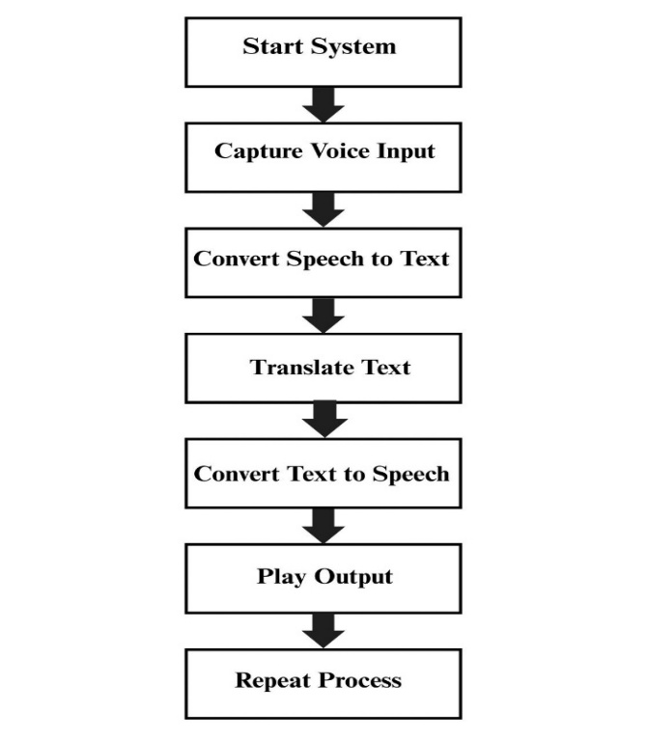
Fig 1: Flow chart illustrating the real-time language translation process.

System Requirements
1. Software Requirements
- Python 3.x
- SpeechRecognition Library
- Googletrans API
- gTTS (Google Text-to-Speech)
- PyAudio
2. Hardware Requirements
- Raspberry Pi 4 Model B
- USB Microphone
- Speaker / Audio Output
- 32GB MicroSD Card
- 5V Power Supply
The Raspberry Pi operates Raspberry Pi OS and serves as the primary execution environment for all Python-based modules in the system.
Project Implementation
1. Language Detection
The initial stage of system operation involves capturing spoken input from the user and transforming it into textual form. Upon system activation, the USB microphone begins recording audio in real time. The SpeechRecognition library processes the incoming signal, applying noise filtering before transmitting audio data to the Google Speech API. The API interprets phonetic patterns and language structures to generate a text output. Simultaneously, the source language is identified using built-in language recognition parameters. The resulting text and language code are then dispatched to the translation module for subsequent processing. This stage is foundational to system accuracy, as errors at this point cascade through the entire pipeline.
2. Translation Algorithm
Once transcribed text and its language metadata are available, the translation algorithm initiates the conversion process. The Googletrans library sends the text along with source and target language identifiers to Google's translation engine, which applies statistical and neural machine translation techniques to produce a contextually faithful output. The translated string is temporarily cached within the system before being routed to the text-to-speech module. Special care is taken to preserve the semantic integrity of the original message throughout the translation process.
3. Text-to-Speech Algorithm
The final processing stage takes the translated text and renders it as human-audible speech. Using the gTTS library, the system identifies and applies the appropriate language-specific voice model. An audio file is generated and immediately played back via the Raspberry Pi's audio output. Post-playback, the temporary audio file is removed from storage to prevent memory accumulation. The system then returns to the idle listening state, ready to process the next spoken input, thereby maintaining a continuous real-time translation loop until manually stopped.

System UML Diagram
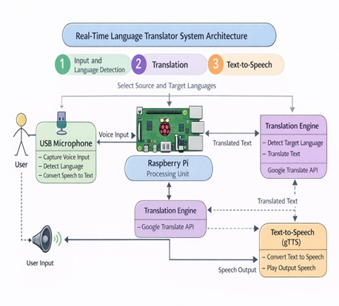

Fig 2: Hardware block diagram showing the interconnection of system components.

Conclusion
This project has successfully demonstrated the design and deployment of a real-time voice translation system using a Raspberry Pi and Python-based NLP libraries. The developed prototype addresses a genuine and widespread problem: the inability of speakers of different languages to communicate effortlessly without external human assistance. By integrating speech recognition, machine translation, and text-to-speech synthesis into a unified embedded platform, the system delivers a practical and affordable communication aid suited to a wide range of real-world scenarios.
The research confirms that modern open-source Python ecosystems, combined with cloud APIs, are sufficient to enable sophisticated language processing on low-cost hardware. The system recorded translation accuracy between 85% and 95%, with performance contingent upon acoustic quality and network conditions. Looking ahead, future iterations of this system may incorporate offline language models to eliminate internet dependency, expand the number of supported languages, improve noise cancellation for challenging environments, and explore deployment on mobile and IoT platforms. Ultimately, this work contributes a meaningful step toward a future where language is no longer a barrier to human connection and understanding.

References
Zhang, Y., et al. (2017). Tacotron: Towards end-to-end speech synthesis with deep neural networks. Proceedings of the 34th International Conference on Machine Learning (ICML 2017).

Ark, S. Ö., et al. (2017). Deep Voice: Neural text-to-speech synthesis in real-time. Proceedings of the International Conference.

Santra, S., et al. (2018). Building a GUI for text-to-speech recognition with natural language processing integration. Proceedings of the International Conference on Computing, Communication, and Automation.

Kamble, K., Kagalkar, R. (2012). A Review: Translation Text to Speech Conversation for Hindi Language. International Journal of Science and Research (IJSR).

Kurzekar, P. K. (2013). A Comparative Study of Feature Extraction Techniques for Speech Recognition System. International Journal of Innovative Research in Science, Engineering and Technology.

Lakshmi, K., Chandra Sekhar Rao, T. (2016). Designs and Implementation of Text to Speech Conversion using Raspberry Pi. International Journal of Innovative Technology and Research, Vol. 4, Issue 6, pp. 4564–4567.

