

Archives available at [journals.mriindia.com](https://journals.mriindia.com/)

## International Journal on Advanced Computer Theory and Engineering

ISSN: 2319-2526

Volume 14 Issue 01, 2025

Computer-Based Cognitive Rehabilitation Systems for Home-Based Training in Pediatric Populations with Developmental Disabilities

1Sakshi Dalvi, 2Manish Sonsale, 3Ranvita Mathapati, 4Himanshu Mahajan, 5Mrs.Asmeeta Mali

1,2,3,4 U.G. Student, Department of Artificial Intelligence and Data Science Engineering, DYPCOEI, Varale, Pune,

Maharashtra, India

5Assistance Professor, Department of Artificial Intelligence and Data Science Engineering, DYPCOEI, Varale, Pune, Maharashtra, India

|  |  |
| --- | --- |
| **Peer Review Information**  *Submission: 23 Feb 2025*  *Revision: 26 March 2025*  *Acceptance: 30 April 2025*  **Keywords**  *Cognitive Retraining*  *Home-based Mediation*  *Incapacities* | **Abstract**  The CCR program (computer-assisted cognitive retraining) offers a new approach to advance children incompetently. This paper examines CCR's ability to live in as a home mediation. The current framework conditions investigation deals with comprehensive techniques and proposed scientific evidence. This consideration addresses the cognitive benefits, challenges and limitations of existing CCR programs. We propose unused frame engineering that points out optimizing availability and commitment to domestic customers. There is a need to discuss future camps for review and improvement in this area. |

**INTRODUCTION**

Impossible children's cognitive impairments present challenges related to daily lessons, socialization and work. Additionally, cognitive retraining takes place in a clinical setting and limits acquisitions based on calculated, budget, and time constraints. The computer controlled cognitive retraining program (CCR) was then developed as a potential agreement to issue home medicines. These programs use this program to include your child in their workout abilities such as memory, considerations, and skills to solve problems. This examines the feasibility of CCR programs in a domestic environment, current framework conditions assessed, and the investigation into the upgrade of openness, commitment, and cognitive outcomes to combat division.

**LITERATURE SURVEY**

Computer Introduction Cognitive Contract Program (CCRPS) CCRP is a software structure tool aimed at improving cognitive functions such as attention, storage, management and problem functions. These programs will reduce in the national environment to support children with colorful disabilities such as mental disorders, Autism Diapathon Complaints (ASD), Awareness/Deficits (ADHD), Brain Palsy and Learning Disabilities. The target population and disability are concentrated in children with specific disorders, including CCRP in Autism Diapathon Complaints (ASD) to improve attention, social cognition, and adaptive gestures in children with ASD. ADHD interventions aim for full attention span, working memory, and impulse control. Learning Disability CCRPS Target Language Processing, Working Memory, Visual Integration. Traumatic Brain Injury (TBI) These programs are used to restore cognitive function and manage attention combinations in children who have recovered from TBI.

We generally used CCRPS-COGMED-WORK memory training for children with ADHD and other literacy disorders. Research shows progress in working memory, but products for academic achievement are inconsistent. Brainhq and Lumosity These programs include exercises aimed at attention, memory and recycling speed. They are popular, but there is a mix of reasons to support the effectiveness of children with disabilities. Cognitive training software used in Rehacoma recreation settings is often used by children with TBI, attention attachment, memory, and management functions. Efficacy and challenged housing-related CCRPs allow children to train at their own pace and comfort, reducing the need to reduce sanitarium visits more frequently. Commitment and Motivation Many CCRPs use gamification to increase child provocation and translate repetitive cognitive tasks into interactive games. Parents participating parents can cover their progress and provide new support during training. The concept of chop's challenge is that it is an important limitation. This is the transfer of chops learned through the program into the actual environment. Some studies report on cognitive progress, but have minimal impact on daily biological live chops or academic achievement. The technical barrier can reduce the effectiveness of CCRP at home by restricting access to technology or internet connections in low-income families. The justification and research of CCRP efficiency and research on research are mixed with positive issues. Some studies have reported advances in relation to attention, working memory, and management functions, particularly in children with ADHD and ASD. Mean/Minimum Revenue 2020 meta-analysis suggested moderate efficiency of cognitive training courses to complete work memory, but used long-term benefits and limited reasons for transfer to academic services. Critical Check Critical reviews of marketable programs such as Lumosity showed revenues for trained tasks and showed minimal broader cognitive progression. Research shows that parents are highly responsible for completing training programs and achieving cognitive progression when they invest effort and encourage their child's participation. Using the software and training your mother to understand your point may also improve the problem.

**METHODOLOGY**

Children with Cognitive Incapacities frequently confront constrained get to to reliable, high-quality cognitive retraining due to calculated and money related boundaries. current computerized frameworks are insulant custom fitted to meet the cognitive and motivational needs of these children in a domestic setting. this inquire about proposes a modern framework design to upgrade ccr availability, adequacy, and engagement for domestic use.

This is a detailed section of a study or overview entitled "Methodology of computerassisted Cognitive Rehabilitation Systems for Home-Based Training in Pediatric Populations with Developmental Disorders . This structure is suitable for papers, research work, or for proposals for grants.

**1. Research Design**

The Mixed Methods approach is used, with a systematic literature overview and exploratory pilot studies combined with children with developmental disabilities. The aim is to assess the design, userfriendly, and effectiveness of computer-assisted cognitive rehabilitation systems for home use.

**2. Participants**

Inclusion criteria: Unless a child aged 5 and aged 5 are integrated with developmental disorders (e.g., hearing loss)

Prevents coexisting mental illnesses that are compliant with training. Intervention: Computerbased Cognitive

Rehabilitation Systems.

The selection of cognitive rehabilitation programs available in stores or in taylormade has been tested. The most important features include playbased cognitive tasks aimed at attention, work memory, executive functions, and visual spatial skills. Procedure.

**3.Basic Assessment**

Parent/Care Interview for Context Understanding to Determine Cognitive Functions in Standardized

Neuropsychological Reviews (e.g. Nepsy-II, Wisc-V-Subtests or Letter-P).

**4.Quantitative Data:**

Paired T-test or Non-Parametric Equivalent for Pre Post Comparison. Regression models (age, basic ability, etc.) Ethical considerations for moderator testing*

Institutional Review Board (IRB)Declaration of consent from caregivers and child consent

Data privacy with encrypted data storage and anonymization.

**EXPERIMENTAL RESULTS**

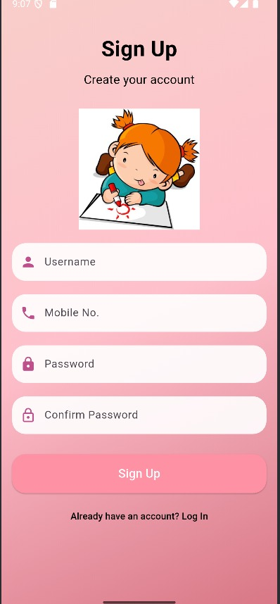Figures shows the results of progress report and level of quiz by using blooms taxnomy algorithm.

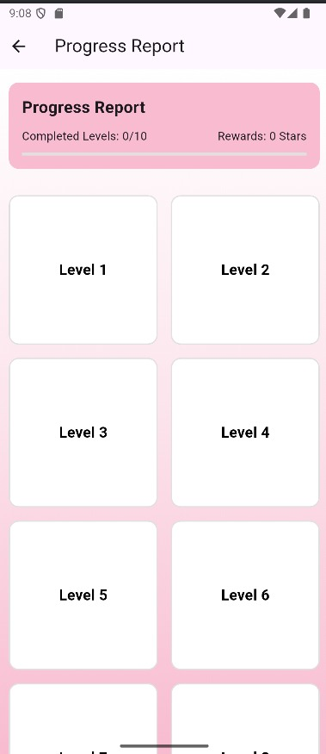

*Fig.(a) Fig.(b)*

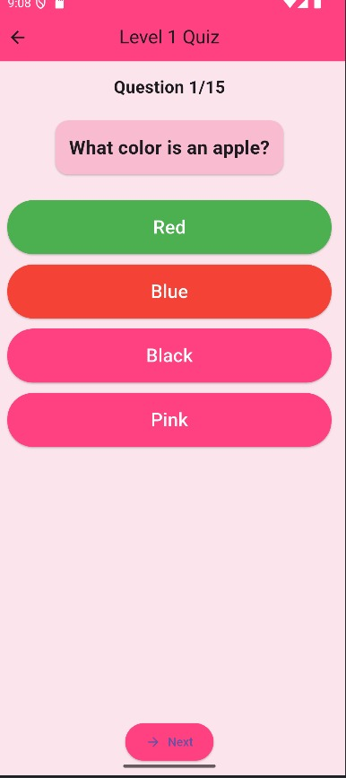 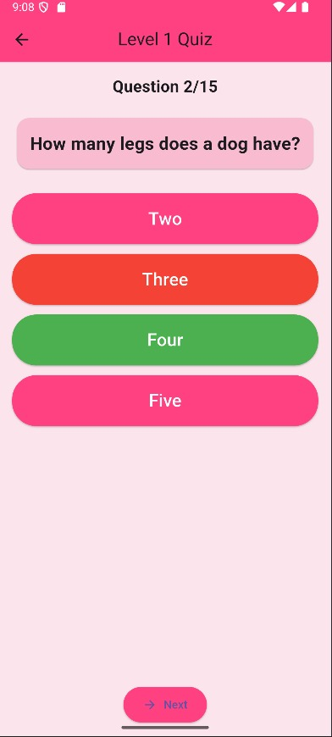

*Fig(c) Fig.(d)*

1. First picture is a sign up pae,sign up page through which we can register in our app.
2. Second picture is a login page.if you have already account go to an login page.
3. Last one is level up page,level up through you can see the levels in our app also has a progress bar on top to see your progress.

**CONCLUSION**

This study was developed to test the use of computer-assisted personalized cognitive training programs. First, 100% of adults with ID/DD in computer aid activities completed their cognitive training program and computer gaming program with appropriate support and supervision. Second, despite the very small sample (n¼11), a clear trend towards cognitive improvement was observed in the cognitive training group. Phase-II research can determine what, even if there are qualitative dynamics such as endogenous factors, motivation, etc. of the person who found the work. Only given the possibility of improving ID/DD, cognitive function. The availability and relatively reasonable price of online cognitive training programs also make it possible to easily use this approach to stimulate the cognitive skills of relatives. The results of this study show that when appropriately adapted to individually adapted devices, computer-aided cognitive stimulation programs for adults with ID/DD may be advantageous. Our research suggests improvements are possible for people with limited cognitive skills.

**FUTURE SCOPE**

# The future of computer-assisted cognitive rehabilitation systems for domestic training in pediatric population groups with developmental disabilities is an important commitment. With the rapid advances in artificial intelligence, machine learning and adaptation technologies, these systems are expected to become increasingly personalized, attractive and effective. Future development allows for real tracking of cognitive progression through intelligent data analysis, enabling child development requirements. Integration into portable devices and virtual reality can further improve user interaction and provide a Unive and Votivative environment that improves attention, memory, and management capabilities. Furthermore, the expansion of Telemedia services supports more accurate cooperation between caregivers and clinics, ensuring that interventions are not only accessible, but also clinically monitored. If accessibility is improved and costs are reduced, these systems can become standard components of early intervention programs, reducing differences in access to quality delivery and supporting long-term development outcomes in children with cognitive impairments.

**References**

1. 1.National Institute of Health. Intellectual and developmental disabilities http://report.nih.gov/NIHfactsheets/ViewFactSheet.aspx ?csid¼100. Accessed June 22, 2013.
2. Vicari S, Carlesimo A, Caltagirone C. Short-term memory in persons with intellectual disabilities and Down’s syndrome. J Intellect Disabil Res. 1995;39(pt 6):532-537.
3. Larson SA, Lakin KC. Changes in the primary diagnosis of students with intellectual or developmental disabilities ages 6 to 21 receiving special education services 1999 to 2008. Intellect Dev Disabil. 2010;48(3):233-238. doi:10.1352/1934-9556-48.3.233
4. Brault MW. Americans With Disabilities 2010. Economics and Statistics Administration, United States Bureau of the Census; 2012. http://www.census.gov/prod/2012pubs/p70-131.pdf. Accessed June 13, 2013
5. . 5. Sinai A, Bohnen I, Strydom A. Older adults with intellectual disability. Curr Opin Psychiatry. 2012;25(5):359-364. doi:10.1097/ YCO.0b013e328355ab26
6. Braddock DL, Hemp R, Rizzolo MC, Haffer L, Tanis ES, Wu J. The State of the States in Developmental Disabilities 2011. Washington, DC: Department of Psychiatry and Coleman Institute for Cognitive Disabilities, the University of Colorado; distributed in collaboration with the American Association on Mental Retardation; 2011.
7. Ward RL, Nichols AD, Freedman RI. Health care inequalities among adults with intellectual and developmental disabilities. Health Soc Work. 2010;35(4):280-290.
8. Hoppestad BS. Current perspective regarding adults with intellectual and developmental disabilities accessing computer technology. Disabil Rehabil Assist Technol. 2013;8(3):190-194. doi:10. 3109/17483107.2012.723239
9. Davies DK, Stock SE, Wehmeyer ML. Enhancing independent internet access for individuals with mental retardation through use of a specialized web browser: a pilot study. Educ Train Mental Retard Dev Disabil. 2001;36(1):107-113.
10. Hegarty JR, Aspinall A. The use of personal computers with adults who have developmental disability: outcomes of an organisation-wide initiative. Br J Dev Disabil. 2006;52 pt 2(103):133-150.
11. Stock SE, Davies DK, Secor RR, Wehmeyer ML. Self-directed career preference selection for individuals with intellectual disabilities: using computer technology to enhance self-determination. J Vocat Rehabil. 2003;19(2):95-103. 12. Hetzroni O, Rubin C, Konkol O. The use of assistive technology for symbol identification by children with Rett Syndrome. J Intellect Dev Disabil. 2002;27(1):57-71.
12. Barnes DE, Yaffe K, Belfor N, et al. Computer-based cognitive training for mild cognitive impairment: results from a pilot randomized, controlled trial. Alzheimer Dis Assoc Disord. 2009;23(3): 205-210.
13. Smith GE, Housen P, Yaffe K, et al. A cognitive training program based on principles of brain plasticity: results from the improvement in memory with plasticity-based adaptive cognitive training (IMPACT) study. J Am Geriatr Soc. 2009;57(4):594-603. doi:10. 1111/j.1532-5415.2008.02167.x.
14. Gu¨nther VK, Scha¨fer P, Holzner BJ, Kemmler GW. Long-term improvements in cognitive performance through computerassisted cognitive training: a pilot study in a residential home for older people. Aging Ment Health. 2003;7(3):200-206.
15. Kueider AM, Parisi JM, Gross AL, Rebok GW. Computerized cognitive training with older adults: a systematic review. PLoS One. 2012;7(7):e40588-e40588. doi:10.1371/journal.pone.0040588
16. . 17. Small GW, Vorgan G. The Alzheimer’s Prevention Program: Keep Your Brain Healthy for the Rest of Your Life. New York, NY: Workman Pub. Co; 2011.
17. Peretz C, Korczyn AD, Shatil E, Aharonson V, Birnboim S, Giladi N. Computer-based, personalized cognitive training versus classical computer games: a randomized double-blind prospective trial of cognitive stimulation. Neuroepidemiology. 2011;36(2): 91-99. doi:10.1159/000323950
18. Pro-Ed. Test of Nonverbal Intelligence, Third Edition (TONI-3). Austin, TX: Pro-Ed; 1997.
19. Haimov I, Hanuka E, Horowitz Y. Chronic insomnia and cognitive functioning among older adults. Behav Sleep Med. 2008; 6(1):32-54. doi:10.1080/15402000701796080
20. Horowitz-Kraus T, Breznitz Z. Can the error detection mechanism benefit from training the working memory? A comparison between dyslexics and controls—an ERP study. PLoS One. 2009;4(9):e7141-e7141. doi:10.1371/journal.pone.0007141
21. Shatil E, Metzer A, Horvitz O, Miller A. Home-based personalized cognitive training in MS patients: a study of adherence and cognitive performance. Neurorehabilitation. 2010;26(2):143-153. doi:10.3233/NRE-2010-0546
22. Verghese J, Mahoney J, Ambrose AF, Wang C, Holtzer R. Effect of cognitive remediation on gait in sedentary seniors. J Gerontol A Biol Sci Med Sci. 2010;65(12):1338-1343. doi:10.1093/gerona/ glq127
23. Haimov I, Shatil E. Cognitive training improves sleep quality and cognitive function among older adults with Insomnia. PLoS One. 2013;8(4):e61390. doi:10.1371/journal.pone.0061390
24. Shatil E. Does combined cognitive training and physical activity training enhance cognitive abilities more than either alone: a four-condition randomized controlled trial among healthy older adults. Front Aging Neurosci. 2013;(5):8. doi: 0.3389/ fnagi.2013.00008